BOOK ORDER FORM FOR AUTHOR VISIT WITH LAURA PURDIE SALAS
Hello, families! Author Laura Purdie Salas will visit with our students on __________. If you’d like to buy an autographed copy of Laura’s books, please complete the form below and return with cash or a check to ______________.
If You Were the Moon – New in Spring 2017!
You'd spin like a twilight ballerina and play dodgeball with space rocks! Find out more in this poetry/science mash-up. (Especially great for 1st-2nd grade and science lovers)

Price: $_____ Order: _____ Autograph to:

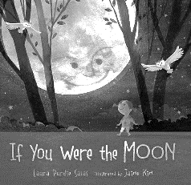
BookSpeak! Poems About Books (NCTE Notable; Minnesota Book Award Winner; Librarians’ Choices; Bank Street Best Books; and more)
In wacky and winsome poems, characters plead for sequels, covers strut their stuff, and parties break out in the bookstore! (Especially great for 3rd grade and up)

Price: $_____ Order: _____ Autograph to:

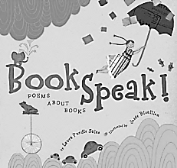
Water Can Be… (Starred reviews; Finalist, Minnesota Book Award; Charlotte Zolotow Recommended Title; Texas Library Association’s 2×2 List; and more)
Explore water and how it creates, changes, and nurtures our world. Rhyming nonfiction with stunning art by Violeta Dabija. (Especially great for K-2nd and art lovers)

Price: $_____ Order: _____ Autograph to:
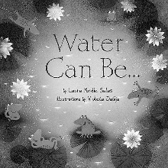
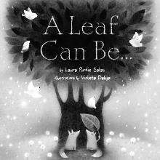
A Leaf Can Be… (Finalist, Minnesota Book Award; John Burroughs Riverby Award for outstanding nature book; Bank Street Best Books; IRA Teachers’ Choice; and more)
A leaf can be a... Shade spiller, Mouth filler, Tree topper, Rain stopper. Discover jobs leaves do in this rhyming nonfiction book. (Especially great for K-2nd and art lovers)

Price: $_____ Order: _____ Autograph to:

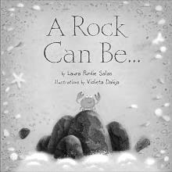
A Rock Can Be…
Rocks can spark a fire, glow in the dark, and help a chicken digest dinner. Rhyming text shows how rocks rock our world! (Especially great for K-2nd and art lovers)

Price: $_____ Order: _____ Autograph to:

Visit laurasalas.com for book details! Please turn in order form and payment by INSERT DATE HERE to INSERT NAME/ROOM # HERE.

Student Name: ______________________________ Grade: _______________
Homeroom Teacher: __________________________ # Books Ordered: ______
$ Enclosed: ______ Name books should be autographed to: _________________

